Menghitung Parameter Graf $SSD_{m}(L_{n})$
$$SSD_{1}\left(L_{n}\right)$$ | $$SSD_{1}\left(L_{2}\right)$$ | $$k=4$$ | $$\left|f\left(u\right)-f\left(v\right)\right|=4+1-d\left(u,v\right) \\ \left|f\left(u\right)-f\left(v\right)\right|=5-d\left(u,v\right)$$
 | $$SSD_{1}(L_{3})$$ | $$k=6$$ | $$\left|f\left(u\right)-f\left(v\right)\right|=6+1-d\left(u,v\right) \\ \left|f\left(u\right)-f\left(v\right)\right|=7-d\left(u,v\right)$$
 | $$SSD_{1}(L_{4})$$ | $$k=8$$ | $$\left|f\left(u\right)-f\left(v\right)\right|=8+1-d\left(u,v\right) \\ \left|f\left(u\right)-f\left(v\right)\right|=9-d\left(u,v\right)$$
 | $$SSD_{1}(L_{5})$$ | $$k=10$$ | $$\left|f\left(u\right)-f\left(v\right)\right|=10+1-d\left(u,v\right) \\ \left|f\left(u\right)-f\left(v\right)\right|=11-d\left(u,v\right)$$
 | $$SSD_{1}(L_{6})$$ | $$k=12$$ | $$\left|f\left(u\right)-f\left(v\right)\right|=12+1-d\left(u,v\right) \\ \left|f\left(u\right)-f\left(v\right)\right|=13-d\left(u,v\right)$$
 | $$SSD_{1}(L_{7})$$ | $$k=14$$ | $$\left|f\left(u\right)-f\left(v\right)\right|=14+1-d\left(u,v\right) \\ \left|f\left(u\right)-f\left(v\right)\right|=15-d\left(u,v\right)$$
 | $$SSD_{1}(L_{8})$$ | $$k=16$$ | $$\left|f\left(u\right)-f\left(v\right)\right|=16+1-d\left(u,v\right) \\ \left|f\left(u\right)-f\left(v\right)\right|=17-d\left(u,v\right)$$
 | $$SSD_{1}(L_{9})$$ | $$k=18$$ | $$\left|f\left(u\right)-f\left(v\right)\right|=18+1-d\left(u,v\right) \\ \left|f\left(u\right)-f\left(v\right)\right|=19-d\left(u,v\right)$$
$$SSD_{2}\left(L_{n}\right)$$ | $$SSD_{2}\left(L_{2}\right)$$ | $$k=4$$ | $$\left|f\left(u\right)-f\left(v\right)\right|=4+1-d\left(u,v\right) \\ \left|f\left(u\right)-f\left(v\right)\right|=5-d\left(u,v\right)$$
 | $$SSD_{2}(L_{3})$$ | $$k=6$$ | $$\left|f\left(u\right)-f\left(v\right)\right|=6+1-d\left(u,v\right) \\ \left|f\left(u\right)-f\left(v\right)\right|=7-d\left(u,v\right)$$
 | $$SSD_{2}(L_{4})$$ | $$k=8$$ | $$\left|f\left(u\right)-f\left(v\right)\right|=8+1-d\left(u,v\right) \\ \left|f\left(u\right)-f\left(v\right)\right|=9-d\left(u,v\right)$$
 | $$SSD_{2}(L_{5})$$ | $$k=10$$ | $$\left|f\left(u\right)-f\left(v\right)\right|=10+1-d\left(u,v\right) \\ \left|f\left(u\right)-f\left(v\right)\right|=11-d\left(u,v\right)$$
 | $$SSD_{2}(L_{6})$$ | $$k=12$$ | $$\left|f\left(u\right)-f\left(v\right)\right|=12+1-d\left(u,v\right) \\ \left|f\left(u\right)-f\left(v\right)\right|=13-d\left(u,v\right)$$
 | $$SSD_{2}(L_{7})$$ | $$k=14$$ | $$\left|f\left(u\right)-f\left(v\right)\right|=14+1-d\left(u,v\right) \\ \left|f\left(u\right)-f\left(v\right)\right|=15-d\left(u,v\right)$$
 | $$SSD_{2}(L_{8})$$ | $$k=16$$ | $$\left|f\left(u\right)-f\left(v\right)\right|=16+1-d\left(u,v\right) \\ \left|f\left(u\right)-f\left(v\right)\right|=17-d\left(u,v\right)$$
 | $$SSD_{2}(L_{9})$$ | $$k=18$$ | $$\left|f\left(u\right)-f\left(v\right)\right|=18+1-d\left(u,v\right) \\ \left|f\left(u\right)-f\left(v\right)\right|=19-d\left(u,v\right)$$
$$SSD_{3}\left(L_{n}\right)$$ | $$SSD_{3}\left(L_{2}\right)$$ | $$k=4$$ | $$\left|f\left(u\right)-f\left(v\right)\right|=4+1-d\left(u,v\right) \\ \left|f\left(u\right)-f\left(v\right)\right|=5-d\left(u,v\right)$$
 | $$SSD_{3}(L_{3})$$ | $$k=6$$ | $$\left|f\left(u\right)-f\left(v\right)\right|=6+1-d\left(u,v\right) \\ \left|f\left(u\right)-f\left(v\right)\right|=7-d\left(u,v\right)$$
 | $$SSD_{3}(L_{4})$$ | $$k=8$$ | $$\left|f\left(u\right)-f\left(v\right)\right|=8+1-d\left(u,v\right) \\ \left|f\left(u\right)-f\left(v\right)\right|=9-d\left(u,v\right)$$
 | $$SSD_{3}(L_{5})$$ | $$k=10$$ | $$\left|f\left(u\right)-f\left(v\right)\right|=10+1-d\left(u,v\right) \\ \left|f\left(u\right)-f\left(v\right)\right|=11-d\left(u,v\right)$$
 | $$SSD_{3}(L_{6})$$ | $$k=12$$ | $$\left|f\left(u\right)-f\left(v\right)\right|=12+1-d\left(u,v\right) \\ \left|f\left(u\right)-f\left(v\right)\right|=13-d\left(u,v\right)$$
 | $$SSD_{3}(L_{7})$$ | $$k=14$$ | $$\left|f\left(u\right)-f\left(v\right)\right|=14+1-d\left(u,v\right) \\ \left|f\left(u\right)-f\left(v\right)\right|=15-d\left(u,v\right)$$
 | $$SSD_{3}(L_{8})$$ | $$k=16$$ | $$\left|f\left(u\right)-f\left(v\right)\right|=16+1-d\left(u,v\right) \\ \left|f\left(u\right)-f\left(v\right)\right|=17-d\left(u,v\right)$$
 | $$SSD_{3}(L_{9})$$ | $$k=18$$ | $$\left|f\left(u\right)-f\left(v\right)\right|=18+1-d\left(u,v\right) \\ \left|f\left(u\right)-f\left(v\right)\right|=19-d\left(u,v\right)$$

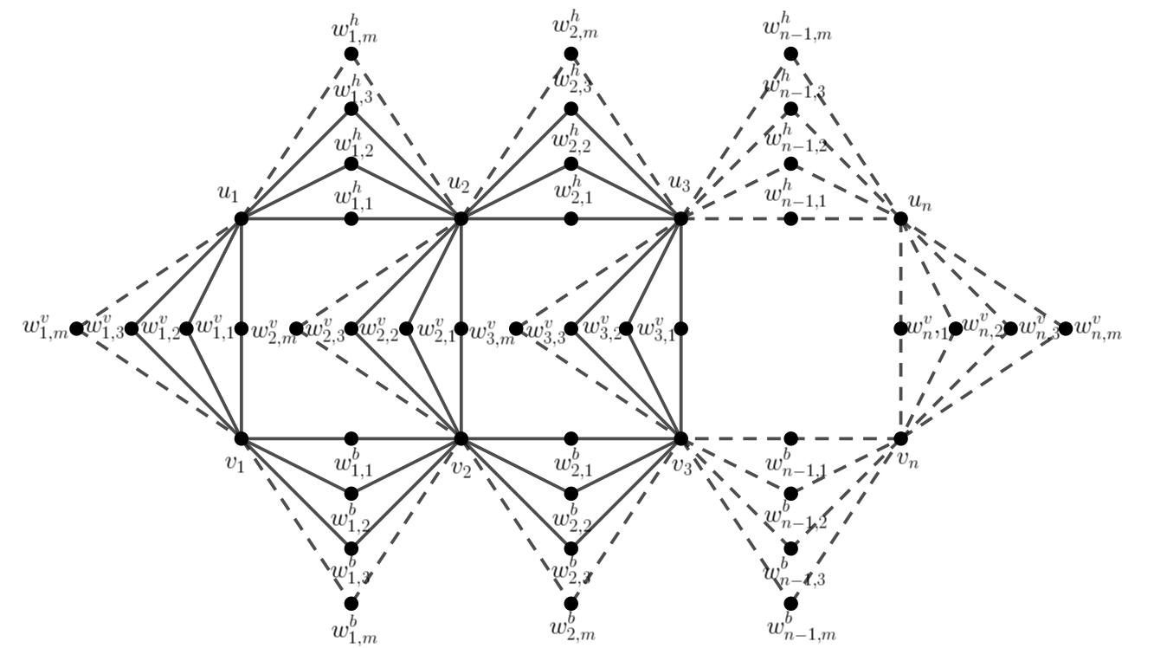
Bentuk Umum $SSD_{m}\left(L_{n}\right)$
$SSD_{m}\left(L_{n}\right)$dengan $m≥1$ dan $n≥2$
Syarat Pelabelan Radio: $\left|f\left(u\right)-f\left(v\right)\right|=diam k+1-d\left(u,v\right)$

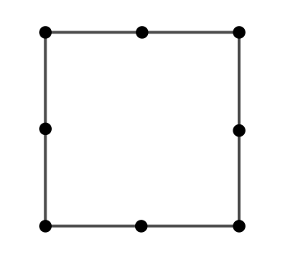
Graf $SSD_{1}\left(L_{2}\right)$

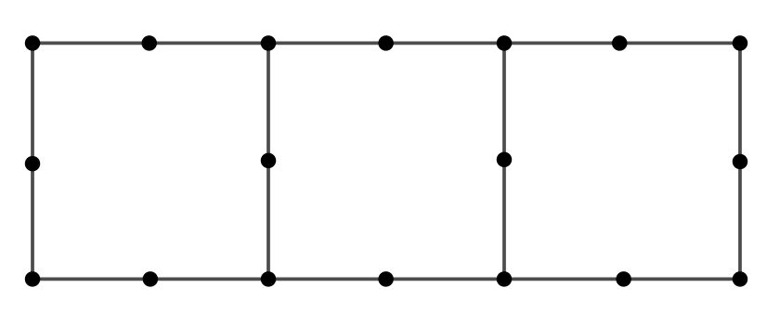
Graf $SSD_{1}\left(L_{4}\right)$
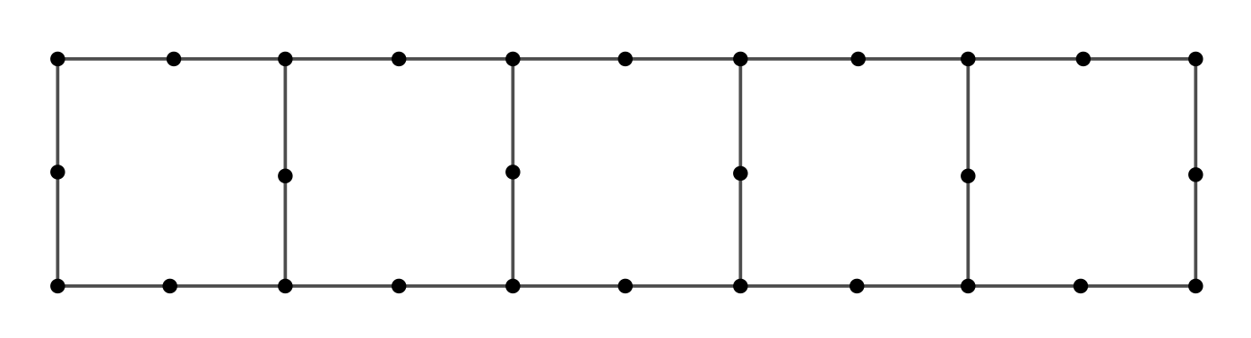
Graf $SSD_{1}\left(L_{6}\right)$

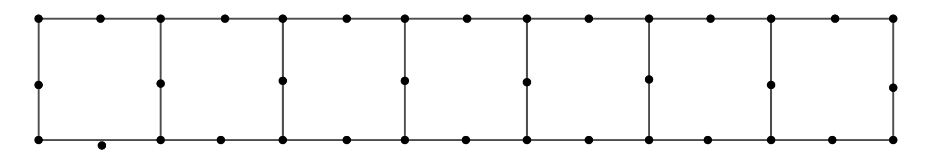
Graf $SSD_{1}\left(L_{8}\right)$

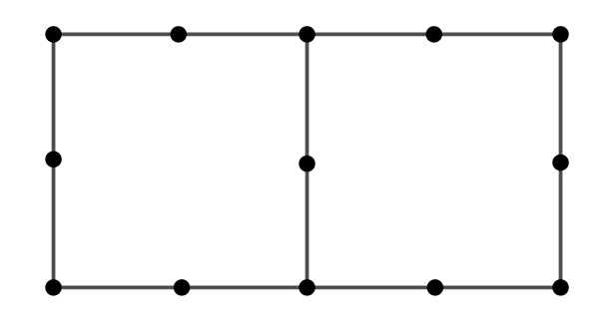
Graf $SSD_{1}\left(L_{3}\right)$

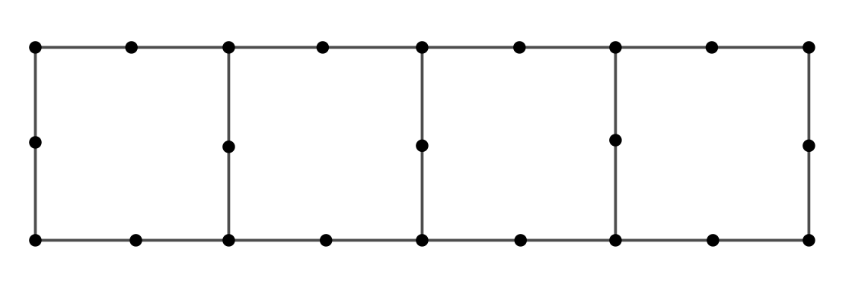
Graf $SSD_{1}\left(L_{5}\right)$
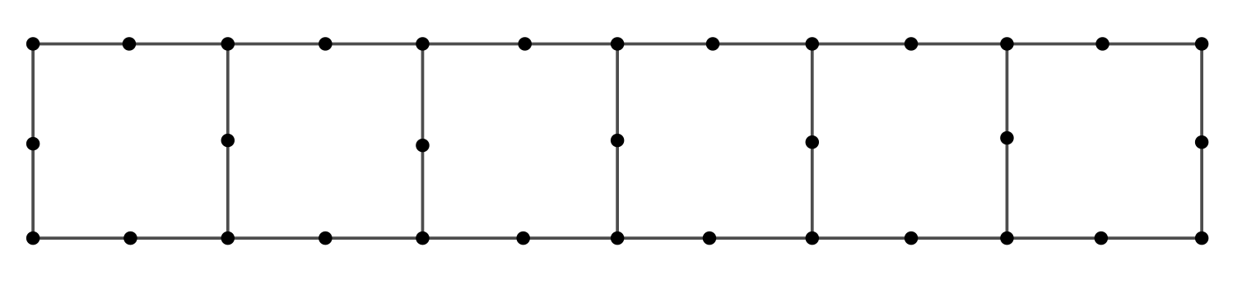
Graf $SSD_{1}\left(L_{7}\right)$

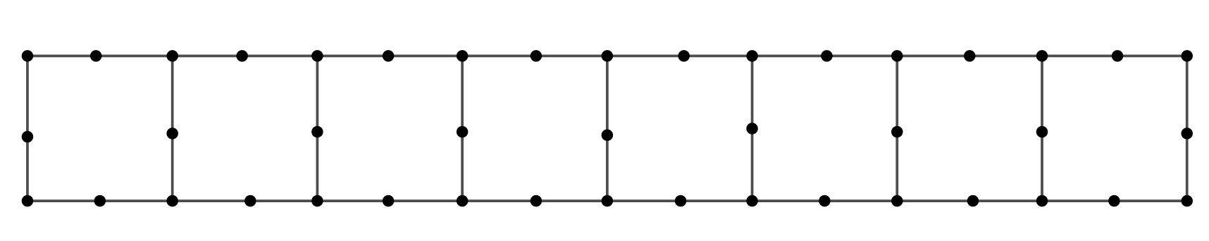
Graf $SSD_{1}\left(L_{9}\right)$

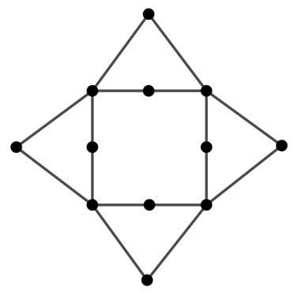
Graf $SSD_{2}\left(L_{2}\right)$

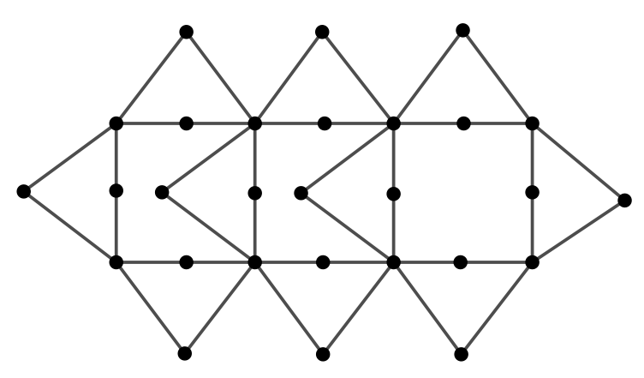
Graf $SSD_{2}\left(L_{4}\right)$
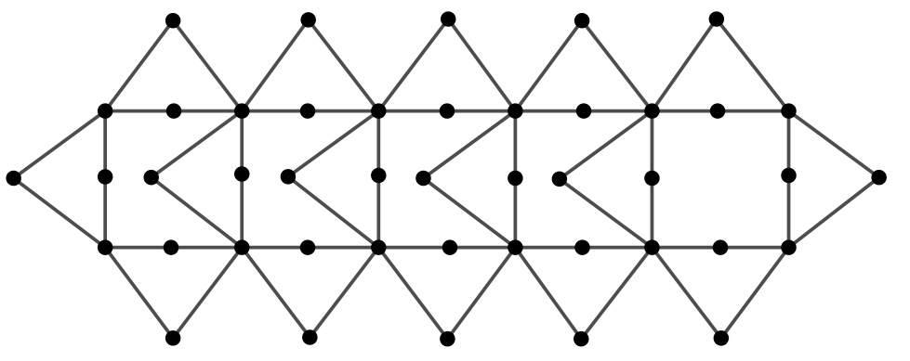
Graf $SSD_{2}\left(L_{6}\right)$

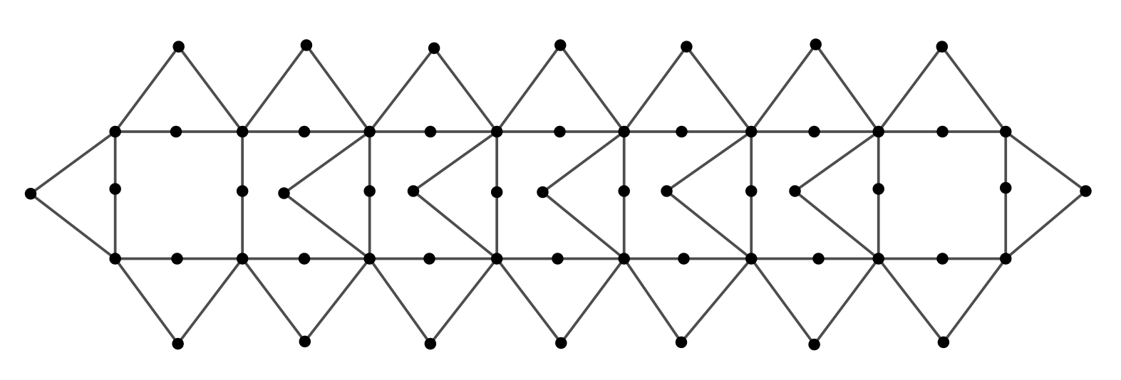
Graf $SSD_{2}\left(L_{8}\right)$
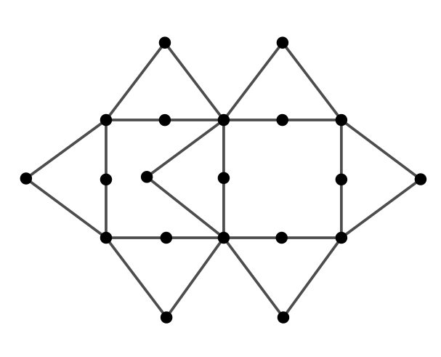
Graf $SSD_{2}\left(L_{3}\right)$

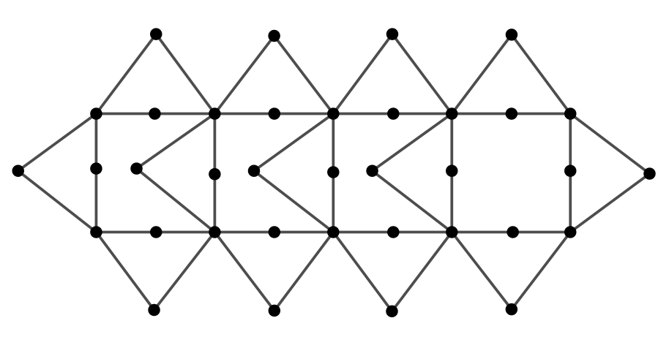
Graf $SSD_{2}\left(L_{5}\right)$
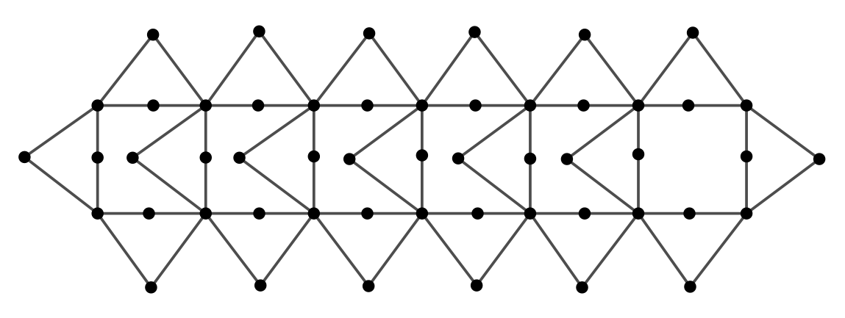
Graf $SSD_{2}\left(L_{7}\right)$

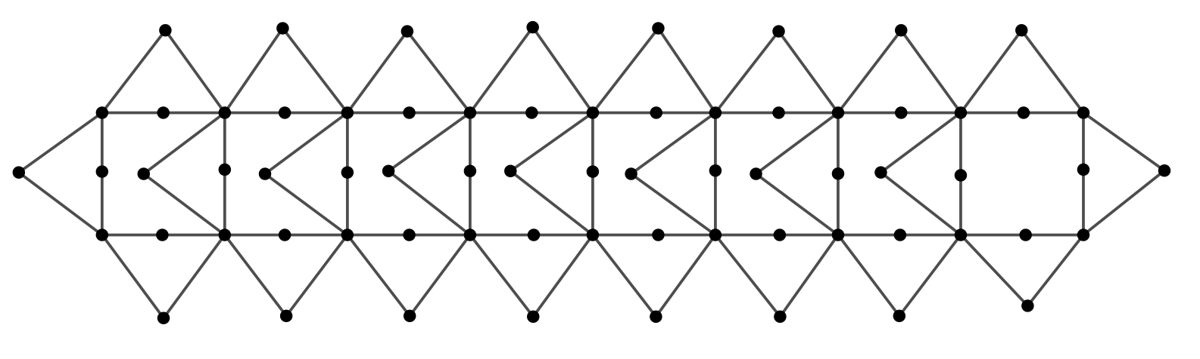
Graf $SSD_{2}\left(L_{9}\right)$
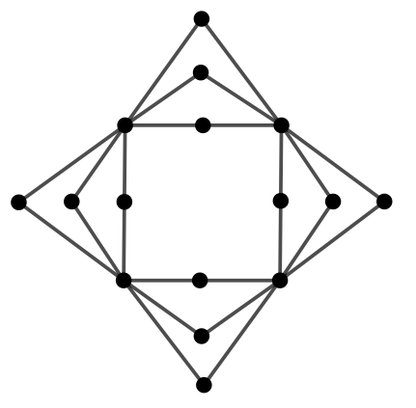
Graf $SSD_{3}(L_{2})$

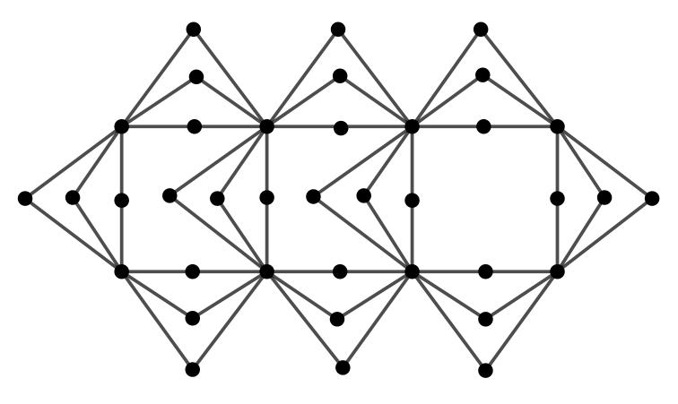
Graf $SSD_{3}\left(L_{4}\right)$
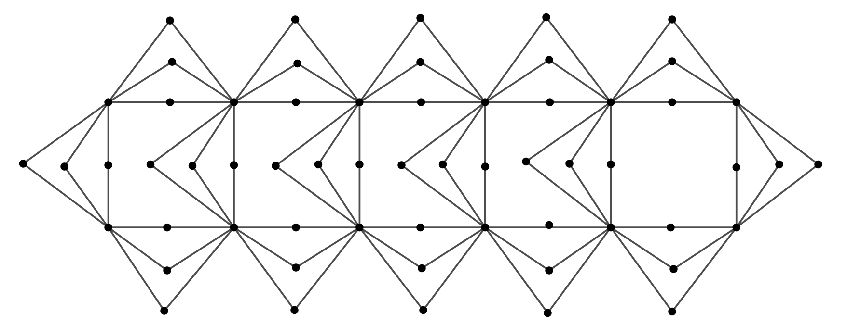
Graf $SSD_{3}\left(L_{6}\right)$

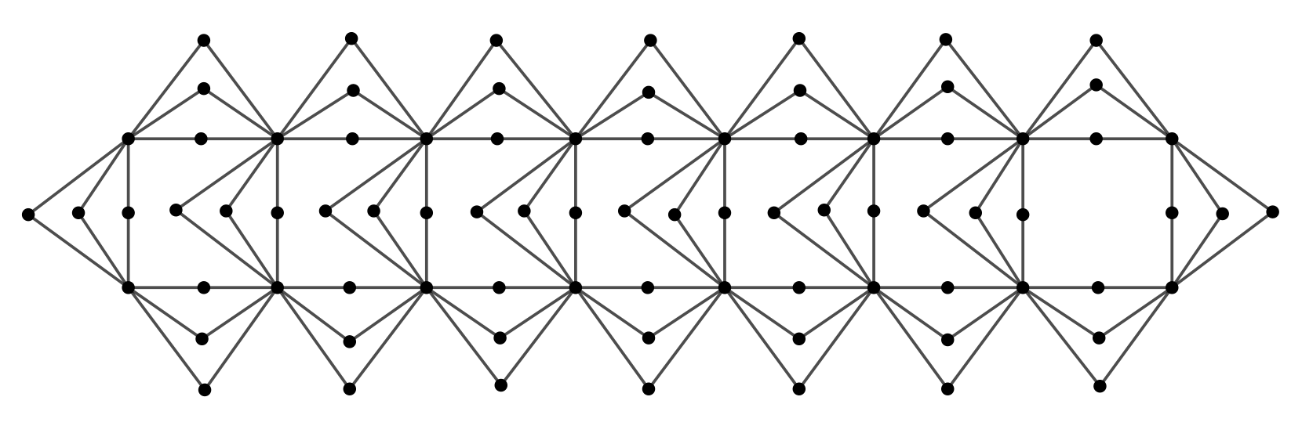
Graf $SSD_{3}\left(L_{8}\right)$
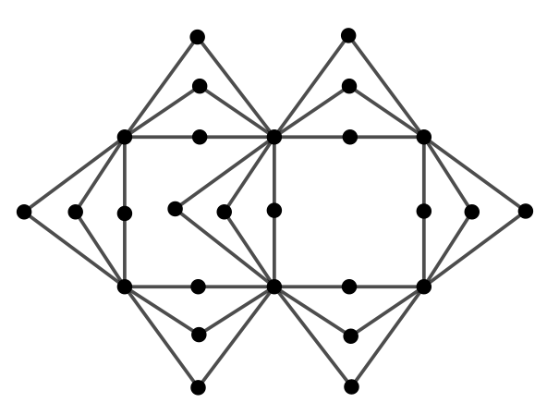
Graf $SSD_{3}\left(L_{3}\right)$

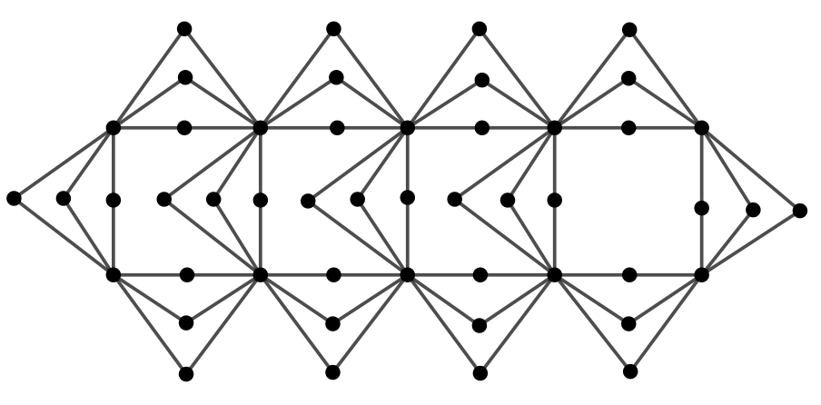
Graf $SSD_{3}\left(L_{5}\right)$
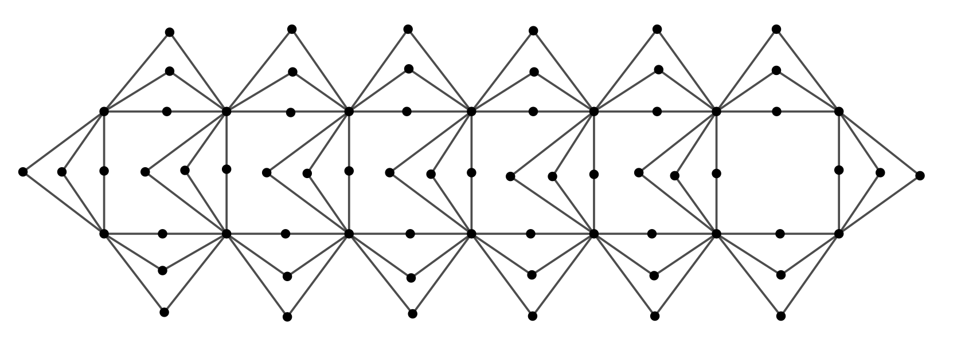
Graf $SSD_{3}\left(L_{7}\right)$
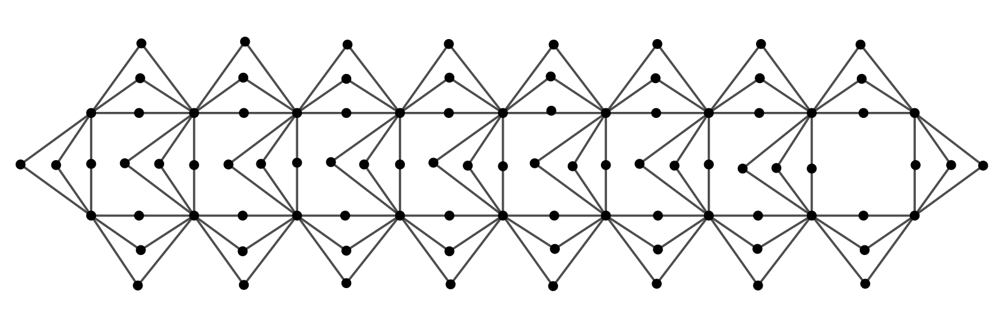
Graf $SSD_{3}\left(L_{9}\right)$

